Shabbos Stories for
Parshas devorim 5783
Volume 14, Issue 45 – 4 Menachem Av 5783/July 22, 2023
Printed L’illuy nishmas Nechama bas R’ Noach, a”h
For a free subscription, please forward your request to keren18@juno.com
Past emails can be found on the website – ShabbosStories.com

Cancelling Tishah B’Av
By Rabbi Sholom Dov-Ber Avtzon

The custom used it be that whenever there was a celebration such as a bris or wedding, a friend or relative would honor the guests with a drink of beer or a similar beverage. There was once a bris on Erev Tishah B’Av, and no one brought any beer. This was as a precaution so the participants would not become intoxicated and be unable to daven Maariv and say Eichah and Kinos properly that night.
The Zeide, who was also at the bris, asked loudly, “Who is honoring the participants with beer?”
Understanding that the Zeide desired that nonetheless beer should be served, one individual announced, “I will distribute beer.” He went home and brought a large quantity of beer, giving each participant a full cup.
Seeing that everything that individual had brought was finished, the Zeide asked once again, “Who will honor us with beer?” Once again someone replied that he would do so, and he gave everyone another full cup. This repeated itself numerous times, and the people drank much more than they were accustomed to.
When night fell and it was time to daven Maariv, there was no minyan to be found. The gabbai went from house to house, hoping to bring some people to help complete the minyan. But in every house he entered the male adults were so intoxicated that they didn't hear his request.
The Zeide walked around the shul snapping his fingers and exclaimed, “Master of the universe! I interfered with you. I am telling You that to be able to help a Jew forget his troubles and sorrow even for a short while is more precious to me than Your Kinos and the entire Tishah B'Av!”

In Yiddish Ich hub dir uhpgiton – (Literal translation is: “I played a good trick on You.”

Reprinted from the current Weekly Story of Rabbi Sholom Dov-Ber

Opening the Gates
of Shidduchim

A fascinating story about the power of forgiveness occurred in Eretz Yisroel. A 38-year-old man, who is hard of hearing, was a passenger on a bus in the city of Ashdod. He had recently gotten closer to Yiddishkeit, and he had decided to cover his head, but not with a Yarmulka. He wore a cap and he was also wearing his work clothes that day.
One of the passengers on the bus was a little tense about a recent wave of terror, and he noticed this man’s dark complexion, and that his cap and clothing were a bit different than the norm. Not realizing that this man was hard of hearing, he also thought his behavior seemed strange, and he suspected that this man was an Arab about to carry out a terror attack.
He told other passengers about his suspicion, and a commotion resulted near this man, who didn’t even notice the tumult due to his hearing impairment. The passengers then approached the driver and told him about the “suspicious” bus passenger.
The driver stopped the bus, approached the man, and after speaking with him briefly, it became clear that the passengers had made a mistake. Understandably, this man was very hurt and embarrassed by the incident, and he told the other passengers that he is not Moichel them, and will not forgive them for what they had done to him.

The Passenger Repeated His Refusal
to Forgive the Other Passengers
The passengers tried to apologize and appease him, but he remained agitated and upset, and he continued to repeat that he’s not Moichel them. One of the passengers who was on the bus later called Rav Chaim Feinstein, Rosh Yeshivah of Yeshivas Ateres Shlomo, and told him about what happened on the bus, and asked him what to do. The Rosh Yeshivah asked to speak with this man personally.
The passenger found this individual and told him that one of the Gedeolei HaDor wished to speak with him. The man agreed to meet the Rosh Yeshivah the next day after Shacharis at the Yeshivah. The next morning, Rav Chaim sat with this man for a long time and spoke with him, taking an interest in his life.
After finding out that he was still single and very much wanted to get married, the Rosh Yeshivah explained to him that if he removed his hard feelings that he had against other people, Hashem would remove any hard feelings that are against him, and the Gates of Shidduchim will open up for him. The Rosh Yeshivah also added that when the Gates of Shidduchim in Shamayim open up, things move quickly.

Offered a Ride to Ashdod
The man accepted the Rosh Yeshivah’s words and said that he forgives the passengers on the bus who suspected him of being a terrorist. As he was on his way out of the Yeshivah, he met a young fellow who happened to be driving to Ashdod, and said he was happy to give him a ride home.
During their conversation on the ride together, it occurred to this young fellow that this man would be a perfect shidduch for his wife’s sister, who was also an older single who recently became closer to Yiddishkeit. Additionally, she also suffered from a medical condition, and she wouldn’t be put off by the man’s hearing impairment. Just a few months later, the couple got engaged, and the L’Chaim was celebrated at the Rosh Yeshivah’s home in Bnei Brak!

Reprinted from the Parshas Pinchos 5783 email of Rabbi Yehuda Winzelberg’s Torah U’Tefilah.

The Far-Reaching Effects
of My Husband's
Mysterious Choice
By Esther Vilenkin

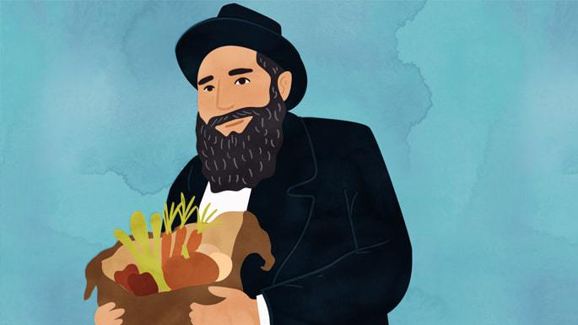
Art by Sefira Lightstone

Last summer, one of our sons was going to an overnight camp in Canada via New York City, and we had plans to drive him there (about an eight-hour trip from Chautauqua, N.Y., where we direct the local Chabad center). We received an update that luggage drop-off necessitated that we arrive a day earlier, changing our plans.
Since we had a pre-existing obligation until 2 p.m. on the afternoon of our departure, our goal was to be all packed and ready to leave immediately afterward. My husband arrived home and noticed that we had a lot of leftover chicken, and so suggested that we make chicken wraps for everyone to eat on the way.
After a quick poll, I saw there was no interest; everyone was already set with their favored packed food. (I also noted that one of my sons was remaining at home and would figure out what to do with the chicken.) For some inexplicable reason, my husband, who was most concerned that we leave right away, decided that he really wanted to make those chicken wraps and was certain that later the children would appreciate them. I was incredulous watching him carefully making them and proudly putting each one neatly in a plastic container. He did a great job, but now we were almost an hour behind schedule.

A Request to Help Someone
Injured in a Car Accident
As we got into the car, my husband asked if I could drive as he felt exhausted. After driving an hour or so, his phone rang. Someone we didn’t know was calling us and asking how far we were from Cuba, N.Y. The caller said he had searched to find the nearest Chabad and Chautauqua popped up. My husband quickly tried searching for Cuba, a small town we had never heard of before. The caller had a sister who had just been in a car accident on the highway near Cuba, and he was looking for someone to help her.
To our amazement, Cuba was on our way; in fact, it was the very next exit—seven minutes away! This just blew our minds! Our timing was perfect; we were absolutely meant to travel a day earlier, an hour later, and approach the exit where we could help a fellow Jew.
We found the woman, and I was able to drive her to Elmira, the closest city with a proper hospital, where she could get appropriate care and evaluation. I stayed with her for a few hours until her family arrived from Cleveland.

The Family of the Accident Victim
As her family pulled into the hospital parking lot, my husband greeted them and asked them if they had something to eat. Hospital waits are unpredictable, and there would be a return trip for them ahead with little chance of finding kosher food. The family was in such a rush to get to the hospital that food wasn’t a priority. They figured they would just make do with whatever kosher items they could buy at a local gas station or grocery.
My husband went back to our car to get them food, and, of course, beaming with pleasure, gave them the chicken wraps. To me, those wraps had G-d’s fingerprints! The chicken wraps didn’t just affect our timing, so that we would be just 7 minutes way from the site of the crash, but also provided nourishment and comfort.
A few days later, we were back in Chautauqua hosting a Friday-night Shabbat meal for a large group. The Torah portion of the week was Matot Massei, recounting the journeys the Jews made in the desert during their 40 years of wandering before entering the Land of Israel. With a Torah message about journeys and the purpose of each encampment, we thought our story of Divine Providence was a perfect example and excitedly shared our experience.
The next morning, a woman came over to me, visibly moved and full of gratitude that my husband shared our story at the Shabbat meal because it meant so much to her family, especially her daughter. It so happened that the previous Sunday, she and her husband were driving to visit their 9-year-old daughter at camp on visiting day. It was the girl’s first experience at an overnight camp.

Delayed by an Unfortunate Flat Tire
Unfortunately, the parents had a flat tire that delayed them for three or four hours. Their daughter watched and waited as her bunkmates went off with their parents. They had promised her that they would visit, but hours passed and they weren’t showing up. By the time they came, she was very emotional, upset and hurt. Even when camp ended and she was back home, it remained a sore subject that lingered in the air.
After having heard the story told by my husband at the Shabbat meal the night before, the girl told her mother, “Now I know why you came late on visiting day!” She went on to explain to her mother that her parents’ delay was part of G-d’s plan for her to help another person.
“You see, there was another girl in my bunk whose parents couldn’t come. While you were fixing your tire, it was just the two of us, but we had each other to play with. G-d wanted my friend not to be alone and the only one without parents or visitors the whole day. For all those hours of waiting, we played together.”

Recognizing the Bigger Picture
She recognized the bigger picture with her important role, and her resentment and hurt feelings were gone. Her mother was so proud and inspired by her daughter’s perceptive and introspective reaction, and so relieved that her daughter processed this all in a manner that calmed her emotionally.
These were the events and details I felt so privileged to witness and be a part of. It seems like an “ordinary story” (no splitting of the sea or amazing phenomena), yet upon scrutiny, Divine Providence is so evident—every piece masterfully orchestrated with precision. Just as experiencing breathtaking beauty is awe-inspiring and points directly to a Creator, being fortunate to see G-d’s hand in the details of our everyday life is humbling and empowering.
Sometimes, you can gaze at an incredible scene: a clear night sky dazzling with millions of endless bright stars, an overlook at the Grand Canyon or the powerful force of Niagara Falls. The majesty of it all is so humbling, especially when considering yourself—one created being—against the scope of the whole universe in all its glory.
At the same time, the Talmud instructs us to consider that, “For me, the world was created.”¹ Each of us affects all of creation; the world would be incomplete without us. The Creator didn’t create spare parts; everyone is the Designer’s original with a unique purpose that cannot be duplicated.

This essay is dedicated to my dear mother, Rebbetzin Tzivya Miriam (Gurary) bas HaRav Yizchak Hacohen, of blessed memory.
FOOTNOTES
1. Sanhedrin 37B.

Reprinted from the Parshat Mattos-Masei 5783 email and website of Chabad.Org

A Future Gadol
By Rabbi Shimon Finkelman

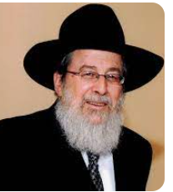
Rabbi Aaron Brafman

Rabbi Aaron Brafman spent the summer of 1968 in Camp Torah Vodaath as a rebbi. Around a decade later, he became learning director of Camp Agudah, a position he held for six years. During the summer of 1979 at Camp Agudah, Rabbi Brafman took a special interest in a camper from London named Yitzchok Meir Morgenstern.
Yitzchok Meir had little interest in playing ball, so Rabbi Brafman offered to learn with him in the afternoon. It did not take long for him to perceive special abilities in this boy. Concerned that the boy’s parents wouldn’t know how to properly help him reach his potential, he took the time to write them a letter:

A Unique Combination of Good Head, Hasmaddah,
Yiras Shamayim and Middos Tovos
Dear Mr. and Mrs. Morgenstern: I have rewritten this letter four times, each time differently, because I want to express myself without sounding ridiculous or creating in you any anxiety about Yitzchok Meir’s potential. I truly feel (as do others) that he is something special. I have seen many bright boys but never the combination of a good head, hasmadah, yiras Shamayim, and middos tovos as one sees in Yitzchok Meir, bli ayin hara.
His joy in learning and his sensitivity and understanding are just beautiful. And it is all natural, not forced, which is why he is a perfectly normal, happy child. I can tell you I felt an aura of taharah and kedushah when I learned with him or talked to him. I felt I had an image (of course our later generations are on lower madreigos) of what the Chofetz Chaim or Chazon Ish might have been like in their youth.
I am not saying this facetiously — he electrified and captivated the whole camp. If this stays with him and he grows in learning, he will someday be a manhig Yisrael. I’m sorry if this makes you feel a bit concerned, because it is an awesome responsibility, but you are blessed with a special matanah.

Predicting a Great Future of Learning for the Young Man
If I may offer some advice: I’m sure he is above his class level, and that could begin to frustrate him. On the other hand, he can’t be out of yeshivah for social reasons and because of a need to avoid the kinah of others. Perhaps you could have someone (who is a talmid chacham, not just an older bachur) tutor him for a while during school time. Have him learn another perek or masechta. Yitzchok Meir will find the time to review it. If he can do this for two or three years, he will become a baki in hundreds of blatt. After that, he probably will finish the rest of Shas on his own at that time.
He should be exposed to people who are gedolim to develop his havanah, and ultimately he will choose and create his own derech in learning. I hope someday to be able to say that I had the zechus of learning with him when he was a bachur. I want to repeat that I have not gone mad. I deal with hundreds of bachurim and have been in chinuch for fourteen years. With best wishes for a kesivah vachasimah tovah and a gut gebentched yahr. Sincerely, Rabbi Aaron M. Brafman P.S. Regards to Yitzchok Meir.
For decades, Rabbi Brafman had no idea what had become of this boy. Around two years before his passing, he paid a shivah call and noticed a framed photo on the wall of someone of saintly appearance whom he did not recognize.

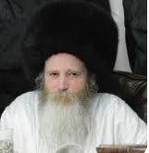
Rav Yitzchok Meir Morgenstern

In response to his question, the avel said that it was Rav Yitzchok Meir Morgenstern, a renowned tzaddik and mashpia in Yerushalayim, a rosh kollel, mekubal, and author of sefarim.
Two weeks later, Mrs. Brafman was introduced to Rav Morgenstern’s sister at a wedding. She told Mrs. Brafman that when her father passed away, they found Rabbi Brafman’s letter in his pocket. When she returned to England, she sent Mrs. Brafman a copy of the letter. Apparently, it had made a huge impact on Mr. and Mrs. Morgenstern and, in turn, on their son.
Later, Rabbi Brafman called two young rebbeim into his office at the beginning of the school year and read to them the letter he wrote to the parents of Rav Yitzchok Meir Morgenstern. Rabbi Brafman wanted these rebbeim to realize the opportunity that they had to impact the life of each and every talmid.

Reprinted from the Parshas Mattos Masei 5783 edition of At the ArtScroll Shabbos Table. Excerpted from the ArtScroll book “Rabbi Aaron Brafman” by Rabbi Shimon Finkelman.
Toras Avigdor Junior
The Story of Our Lives
By Aharon Spetner

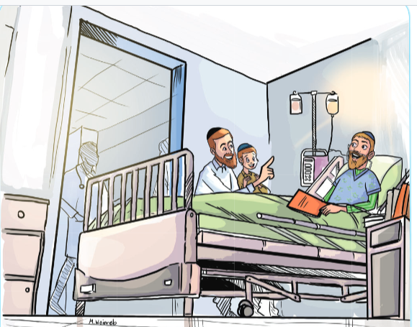
Illustration by Miri Weinreb

Yitzy walked nervously with his father down the hallway of the hospital floor. He always felt uncomfortable seeing the various sick people attached to all sorts of scary-looking equipment. Finally, they reached Uncle Refoel’s room. Uncle Refoel had been very sick for the past six months and Yitzy often went to visit him.
It looked like Uncle Refoel was just finishing a discussion with a doctor when they walked in.
“Wow, Boruch Hashem! This is amazing news! Thank you so much!” Uncle Refoel said with a huge smile as the doctor packed up his things and left.
Totty rushed forward. “Refoel, what’s going on?” he asked with a hopeful look on his face.
Uncle Refoel’s eyes glistened with tears of joy. “It’s a neis!” he said.
Yitzy walked nervously with his father down the hallway of the hospital floor. He always felt uncomfortable seeing the various sick people attached to all sorts of scary-looking equipment. Finally, they reached Uncle Refoel’s room. Uncle Refoel had been very sick for the past six months and Yitzy often went to visit him.
It looked like Uncle Refoel was just finishing a discussion with a doctor when they walked in.

Grateful for the Amazing News
“Wow, Boruch Hashem! This is amazing news! Thank you so much!” Uncle Refoel said with a huge smile as the doctor packed up his things and left.
Totty rushed forward. “Refoel, what’s going on?” he asked with a hopeful look on his face.
Uncle Refoel’s eyes glistened with tears of joy. “It’s a neis!” he said. “The doctor came and said that the latest tests show that the disease is completely gone! I can leave the hospital tomorrow!”
Totty and Yitzy were overjoyed. “Boruch rofei cholim!” they exclaimed.
Totty turned to Yitzy, who had started stacking up some of the things next to Uncle Refoel’s bed, “What are you doing, Yitzy?”
“Well, he’s leaving tomorrow,” Yitzy said, picking up a notebook and placing it together with a stack of seforim. “I thought I’d help him get his stuff together.”
“Oh, Yitzy you’re so sweet,” Uncle Refoel said. “But would you mind actually giving me that notebook? I need to write something down.”

A Notebook Filled with Many
of Dates and Medical Notes
Yitzy handed over the notebook and as Uncle Refoel opened it he saw that it was filled with pages and pages of dates and medical notes:
• 3 Sivan 5783 - Doctor says things are worse than ever
. 9 Sivan 5783 – Started new mediction, feeling dizzy.
• 15 Sivan 5783 - Feeling a bit better
• 3 Tamuz 5783 - Underwent emergency surgery
• 15 Tamuz 5783 - Blood test
Yitzy then watched as Uncle Refoel added a new line:
• 24 Tamuz 5783 - Boruch Hashem, the doctors say I’m better!
Uncle Refoel closed the notebook and handed it back to Yitzy with a smile.
“Uncle Refoel,” asked Yitzy. “Why did you keep notes of everything that happened to you here? I understand that you want to remember today when you got the good news, but a lot of the things you wrote down sound very scary!”
Uncle Refoel adjusted himself and Yitzy flinched as he saw the IV line going into Uncle Refoel’s arm. “Yitzy,” he said, “In this week’s Parsha the Torah spends a tremendous amount of pessukim telling us every single place the Am Yisroel stopped in their 40 years in the Midbar. Doesn’t that sound a bit strange?

The Importance of Every Single Step
in Everyone’s Journey thru Life
“But Rav Avigdor Miller says that it’s not just where we end up. Every single step in our journey through life is important. Everything that happens to us is from Hashem and each little detail, no matter how unimportant or even painful it may seem, is for our good! That’s why remembering each little thing Hashem does for us is super important if we want to be true ovdei Hashem.
“I went through many painful things in the hospital: surgeries, blood tests, scary news from the doctors. But I know that each and every little thing was actually a gift from Hashem to help me grow and become closer to Him. And now that I am leaving the hospital I have a notebook filled with everything that happened and I can look back through it and remember all of the gifts Hashem gave me along the way.”
“Incredible,” said Yitzy, very impressed.
“But I want to tell you one more thing, Yitzy,” Uncle Refoel continued.
“You’ve done an incredible mitzvah coming to visit me all these months. I really owe you a lot of hakoras hatov. But I noticed that you always seemed somewhat uncomfortable around me and the other sick people here.”

The Lesson from Seeing Sick People
“Well, yeah,” Yitzy said. “It’s scary to see sick people. It makes me afraid and I don’t know what to think or say.”
Yitzy thought he might have hurt his uncle’s feelings, but Uncle Refoel continued smiling. “Yitzy,” he said, “Do you know what Rav Avigdor Miller says that we should say whenever we see a sick person?”
“Refuah Shleimah?” Yitzy asked.
“Yes,” said Uncle Refoel, “but that’s what you say out loud. To yourself you have to say ‘thank you Hashem for not making me sick like that person, thank you Hashem that I am healthy and don’t need to be in a hospital!’ Whenever you see a sick person, it’s Hashem Who is reminding you that you are healthy and we need to recognize and be aware of that all the time!”
Totty and Yitzy said their goodbyes to Uncle Refoel and left. As they walked through the lobby and passed a boy in a wheelchair with a broken leg, Yitzy asked Totty if he could borrow his pen.
Yitzy then took out a piece of paper from his pocket and wrote down “24 Tamuz 5783 - visited Uncle Refoel - Boruch Hashem he’s better! And I saw a boy with a broken leg - Boruch Hashem I have two healthy legs!”
Have a Wonderful Shabbos!

Takeaway:
Our lives are a story Written by Hakadosh Baruch Hu. Our parsha teaches us to remember the entire story and thank Hashem for every step of the way.

Reprinted from the Parshas Mattos-Masei 5783 edition of Toras Avigdor Junior, adapted from the teachings of Rav Avigdor Miller, zt”l.

A Dispute Between Two
G-d Fearing Partners

In the period between the First and Second World Wars there lived a pious Jew named Yehuda Schwartz, in the central Hungarian village of Mezutzat. Reb Yehuda was the proprietor of a small tavern located next to the railroad station.
Most of Reb Yehuda’s business was conducted with the local wine growers, from whom he purchased his supplies. Some of the wine was served in his tavern, while the rest was sold to wholesalers in the larger cities.

A Partner is Brought into the Business
The business grew until eventually Reb Yehuda brought in a partner, a Jew by the name of Hopstatter. Over the course of time a clear division of labor was established: Schwartz traveled from village to village buying the wine from the vineyards, while Hopstatter dealt with the wholesalers and other merchants. All payments he received were handed over to his partner, who could then pay the wine growers whatever they were owed.
At the end of each season, after the wine had been fully fermented and sold, the two partners would sit down to do their books. Both men were G-d-fearing individuals, and the two partners trusted each other implicitly. Not even once had they argued over figures or the division of profits.
One time, however, it happened that each partner made his calculations separately, with drastically different results. Hopstatter claimed that he had given 10,000 kronen to Schwartz, while Schwartz insisted that he had never received the money. After going over their records a second time with the same results, they decided to go to the Rabbi.
In those years, the legal authority in the village was the famous Rabbi Yehuda Altman, author of the scholarly work, Yam Shel Yehuda. The Rabbi listened carefully as the two sides presented their respective cases.
Standing before him were two good men, ethical and honest. Each was convinced he was speaking the truth. Hopstatter insisted that he remembered putting the bundle of money in his partner’s hand. Schwartz was equally adamant that it never happened. Unfortunately, neither partner had any documents to back up his claim.

The Rabbi Asks the Defendant to Take an Oath
In such cases, the Rabbi had no choice but to ask the defendant to take an oath. Hopstatter declared that he was willing to swear, but Schwartz was dead set against it. As it was patently obvious that his friend was mistaken, Schwarz argued, he had no desire to cause him to commit the sin of taking a false oath.
“I am against it on principle,” he continued. “If the tables were turned and I were asked to swear to the truth, I wouldn’t do it even then. How much more so am I opposed to it now, when I see my friend about to stumble.” At that point Schwartz announced that he was dropping his claim against Hopstatter. The 10,000 kronen weren’t that important...
The two partners looked at the Rabbi expectantly, awaiting his verdict. After a brief moment he pronounced that as there was no longer any case pending, there was no need for an oath, and everyone could go home.

A Casual Acquaintance Visits the Tavern
A short time later a vendor who was a casual acquaintance of Reb Yehuda Schwartz visited the tavern. In the course of conversation, Reb Yehuda mentioned the recent misunderstanding he had had with his partner.
“Hey, wait a minute,” the vendor said as a thought occurred to him. “I might be able to tell you something that can shed a little light...
“A few months ago, I was making my rounds at a certain inn, and I bumped into your friend Hopstatter. I didn’t really talk to him, but I noticed him speaking to the owner. At a certain point a third man, someone I didn’t recognize, walked in and went over to Hopstatter. The two men shook hands, whereupon Hopstatter took out his wallet. I saw him remove a bundle of money tied with a string and hand it to the stranger. The stranger then sat down at a side table and counted the bills. When he was satisfied it was the proper amount he left the premises.”
Immediately, Schwartz wrote a letter to his partner describing the incident, and asked if it had any significance. After mailing the letter he returned to work.
About a week later a carriage pulled up in front of the tavern, discharging a rather emotional and distraught Hopstatter. Rushing inside he practically fell upon Schwartz, hugging and kissing him. “I can’t believe it!” he cried. “You saved me!”
He related that although he clearly remembered preparing the bundle of money for his partner, he had completely forgotten that he had given part of it to the man at the inn.
That evening Hopstatter told everyone in the synagogue the story of what had happened, and invited everyone to a festive meal in honor of his dear friend, who had prevented him from committing a grave sin.
Reb Yehuda Schwartz was murdered by the Nazis (may G-d erase their name) in June of 1944. This story was told by his great-grandson, Avigdor Sharon of Israel.

Reprinted from the Parshat Matot-Masei 5783 edition of L’Chaim, a publication of the Lubavitch Youth Organization in Brooklyn, NY.

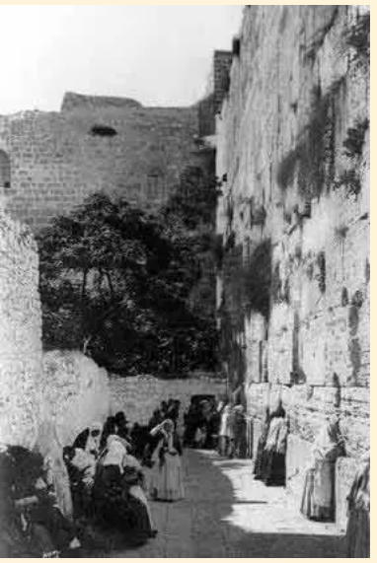
Photos of Jews praying at the Western Wall, circa early 20th Century

